GU OS

Technical Architecture, Operating Model & Evolution Blueprint
Master technical reference for Product, Engineering and Cofounders
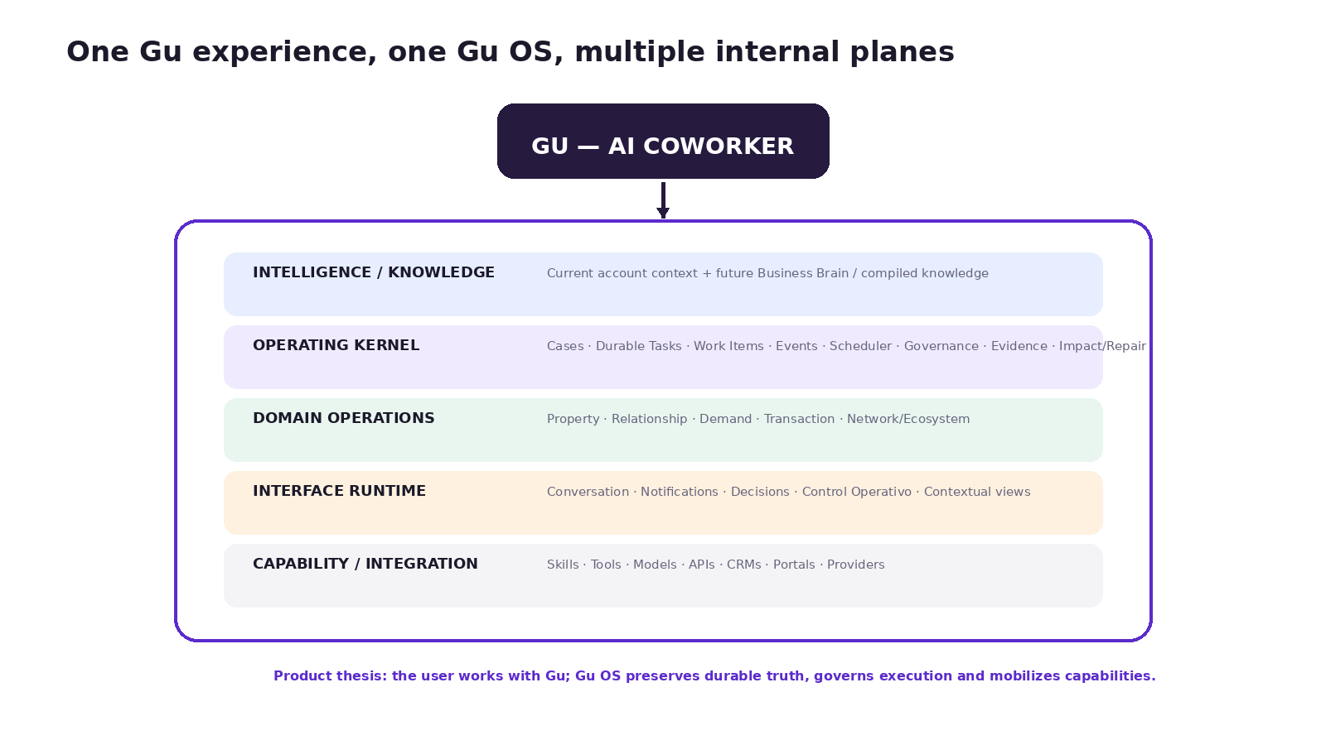
Version | 1.0
Repository snapshot | main · 49d5f176f744fa67021b5874e2c4d0c43a5cbc96
Snapshot date | 23 Aug 2026
Internal narrative references | Investor Narrative Backbone v0.6 · Team Primer v1.2 · Cofounder Strategic Vision v1.1

Internal / Confidential — architecture status is evidence-based and must be revalidated as the repository evolves.

How to use this document
Purpose
This document is the deep technical source from which the Session 2 architecture presentation should be derived. It reconciles current repository behavior, accepted target architecture and the product/business model already established in the internal narrative documents. It is not a replacement for canonical repo plans; when a technical detail conflicts, the repository authority order below wins.

The central discipline is to separate three questions that were previously easy to blur: (1) what exists in code today, (2) what is an accepted architectural target, and (3) what is product/strategy synthesis that still requires implementation or validation. The document therefore uses the repository status vocabulary consistently: Implemented, Partial, Target, Tentative, Open and Reference.
A second discipline is to keep product abstractions and runtime abstractions connected without pretending they are identical. “Relationship Operations”, “Demand Operations” and “Network Operations” are product/domain frames. operational_cases, work_items, case_facts, workflow_definitions, Skills, Tools and executor adapters are runtime primitives. The objective is to show how the latter can support the former.
A third discipline is to preserve the One Gu model. Gu is the user-facing AI coworker; Gu OS is the operating environment underneath. Internal planes and subsystems may be modular, but they should not become a collection of independently branded bots or applications.

Status vocabulary
Status | Meaning | How this document uses it
Implemented | Present in current migrations/code and usable under its documented flags. | We can treat the capability as repository reality, while still noting rollout or product-proof limits.
Partial | Important runtime pieces exist, but end-to-end behavior, rollout, environment coverage or product proof is incomplete. | Used heavily for Studio, attachments, durable-task UX and other foundations that are real but not fully released.
Target | Accepted architectural direction that may not yet be fully implemented. | Used for Business Brain, general Case Supervisor / agent-proposed dynamic work, richer contextual UI and broader domain operations.
Tentative | Proposed name/schema/interface still requiring implementation validation. | Never described as if it already exists.
Open | A product/domain/architecture decision still requiring explicit resolution. | Collected in the risk/open-decision section.
Reference | Historical or external material useful as a design lens. | Does not override canonical Gu OS architecture.

Source basis: `docs/README.md` authority and status vocabulary; `docs/manuals/gu-os-flexible-workflows-technical-plan.md` evidence legend.

Contents
1. Executive Architecture Summary | 14. Skills, Tools, Providers and OWN / ORCHESTRATE
2. Source Authority, Evidence Method and Reconciliation | 15. Conversational Runtime, Multi-Intent and Cross-Channel Continuity
3. Product-to-Architecture Mapping | 16. Dynamic / Contextual UI and Artifacts
4. Current System Baseline | 17. Operational Domains
5. Architectural Principles and Invariants | 18. Traditional Gu → Gu OS Evolution
6. Core Abstraction Model | 19. Workflow Studio and Compiler
7. Case Plane and Operational Truth | 20. Observability, Testing, Cost, Safety and Tenancy
8. Work Plane and Dynamic Execution | 21. Current vs Target Architecture
9. Executors and Capability Resolution | 22. Recommended Technical / Product Roadmap
10. Human Involvement and Governance | 23. Risks, Open Decisions and Technical Debt
11. Verification, Evidence, Impact and Selective Repair | Appendix A. Architecture Reconciliation Matrix
12. Eventing, Scheduling and Proactivity | Appendix B. Glossary
13. Business Brain and Knowledge Architecture | Appendix C. Source Register

1. Executive Architecture Summary
Gu OS has moved materially beyond the architecture snapshot that informed some earlier internal documents. The repository now contains not only the original conversational agent, Skills, Tools, HITL, Heartbeat and Operational Cases, but also versioned workflow authority, a first-class Work Plane, capability-based executor profiles, an Impact Plane with case_facts / artifacts / evidence-bound approvals, conservative multi-intent decomposition, a substantial Workflow Studio/compiler surface, and first-class Durable Task roots. These are implementation facts, not merely target diagrams.
At the same time, the most ambitious product concepts remain appropriately ahead of the current runtime. A general Case Supervisor that freely constructs or revises agent-proposed work graphs is still an evolution target; the agent_proposed work-item seam exists but general dynamic activation remains gated. The future Business Brain / Brain Layer remains a target architecture; the current profiles.business_brain object is a much narrower account-context and data-binding mechanism. Relationship Operations and Demand Operations are product/domain directions that the common kernel is increasingly capable of supporting, but they are not yet broad, production-proven domains.
The most important reconciliation finding
The implementation is farther along than the earlier Team Primer status language suggested, while the product proof is not. Gu OS now has a substantial technical foundation; broad customer production validation, the Lead Opportunity / Relationship Operations product layer, outcome correlation and the future Business Brain remain the next proof points.

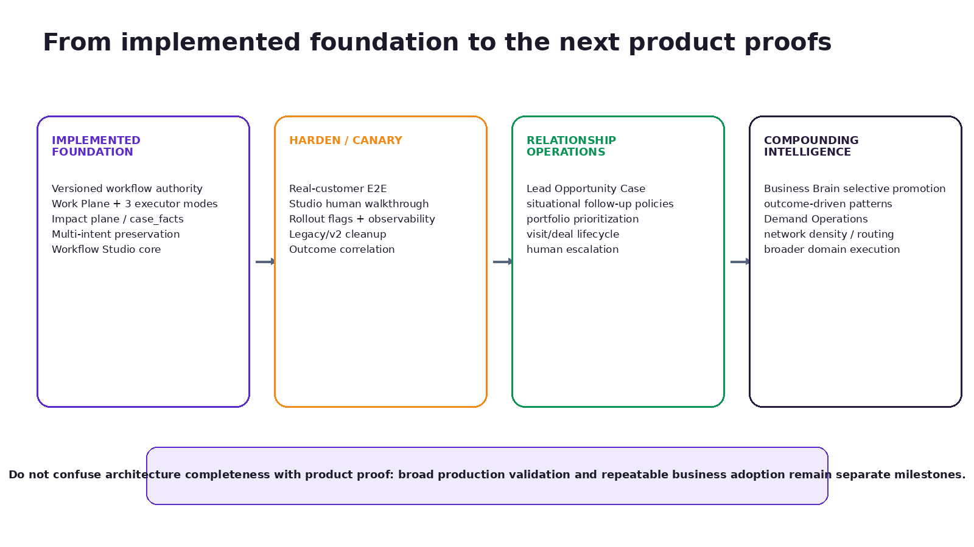
Figure 1 — Repository reality is ahead of some earlier architecture narratives, but product proof and broader domain rollout remain distinct milestones.

Architecture in one paragraph
Gu OS is a brownfield, governed agentic operating environment built around a LangGraph conversational runtime and a durable execution substrate. Conversation is an interface and high-value context source, not the sole operational state. Operational Cases represent multi-day business procedures; Durable Tasks represent independent durable jobs that should not be forced into commercial Cases. A shared Work Plane decomposes durable roots into Work Items with explicit dependencies, attempts, claims/leases and executor selection. Versioned workflow definitions, deterministic evaluators/guards, evidence records and human involvement keep model reasoning inside enforceable boundaries. The Impact Plane makes input→artifact→approval dependencies explicit so changes can trigger selective repair rather than full replay. Business Brain is the future cross-Case cognition layer and must not become a second action queue or source of operational authority.

What is already implemented
- Conversational runtime on web and Telegram using LangGraph, OpenRouter-hosted models, Supabase Auth/Postgres, Skills and Tools.
- Personal long-term memory, short-term/checkpoint state, scheduled tasks and Gu OS Heartbeat.
- Operational Cases with state, events, next_action_at, waits, reminders, internal/external response handling and Case-bound execution.
- Versioned workflow definitions, pinned definitions, runtime transition evaluator/guards, historical replay and an enforcing pilot mode.
- Work Plane tables and dispatcher: Work Items, dependencies, attempts, claims/leases, liveness, retries and work-item events.
- Three executor modes: main agent, deterministic service and human; worker profiles and scope enforcement.
- Impact Plane: case_facts, case artifacts, declared artifact inputs, evidence-bound approvals, selective staleness and repair work.
- Conservative multi-intent decomposition around pending decisions with residual-intent preservation.
- Workflow Studio/compiler foundations with business/implementation specs, capability mapping, validation gates, simulation, evidence-gated publication and NL authoring foundations.
- Durable Tasks + Work Runs as first-class non-Case durable roots.
- AI usage metering, Control Operativo views, impact views, self-tests/CI infrastructure and live/synthetic work-plane soak evidence.

What is not yet equivalent to the product vision
- A broadly deployed Case Supervisor that dynamically constructs and replans arbitrary work graphs from live context. Current work graphs are substantially definition/repair-driven; general agent_proposed work remains gated.
- A production Business Brain with compiled cross-Case entity truth, graph, signals and governed promotion. Current business_brain is not that architecture.
- Persistent Lead Opportunity / Relationship Operations as a production domain replacing fixed follow-up behavior in traditional Gu.
- Broad Demand Operations with campaign→lead→visit→outcome feedback and optimization.
- Generated/contextual UI as a generalized runtime surface across tasks and channels. Current operator/Studio views are real; the broader adaptive-interface vision is target.
- Full cross-channel antecedent continuity for non-Case result sets. Current product is multi-channel with shared business state, not a universal omnichannel transcript.
- Broad customer production validation, repeatable deployments and market canaries across the new architecture.
Source basis: Current repo: `docs/architecture.md`, `docs/manuals/architecture-manual.md`, `docs/operational-cases/architecture.md`, flexible-workflows Detailed Implementation Plan, migrations 00069/00070/00074, `packages/workflows/src/*`, Workflow Studio docs. Product synthesis: Investor Narrative Backbone v0.6, Team Primer v1.2, Cofounder Strategic Vision v1.1.

2. Source Authority, Evidence Method and Reconciliation
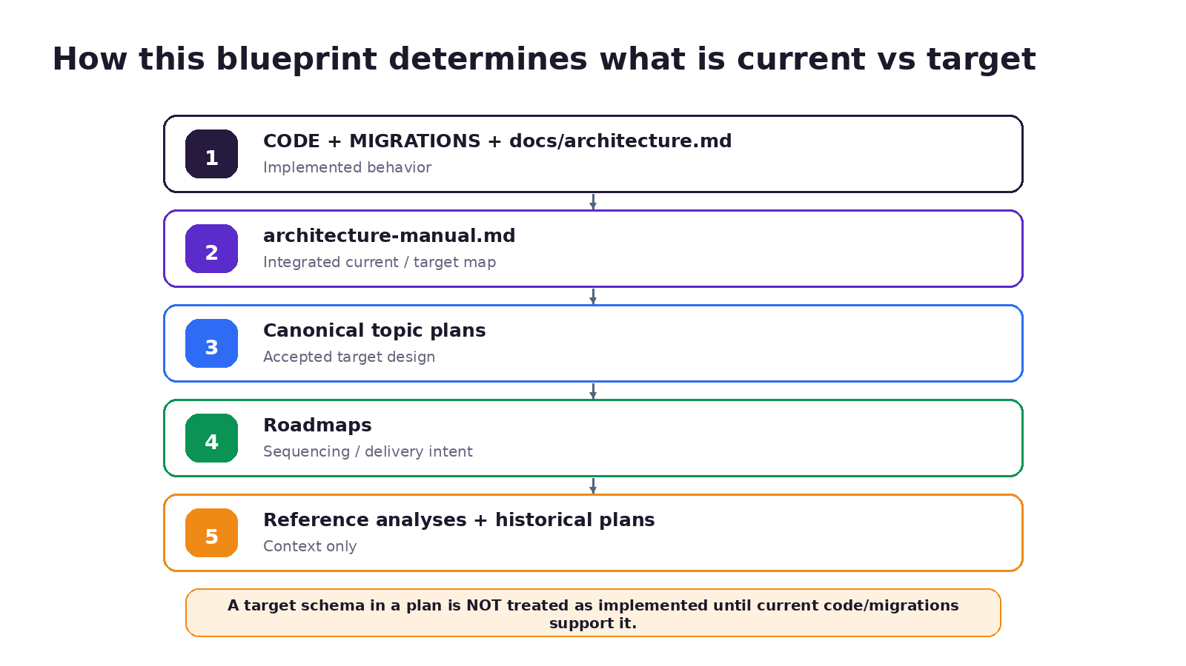
Figure 2 — Repository authority order used for this blueprint.
The repository explicitly defines an authority order. Implemented behavior is determined first from current migrations, code and docs/architecture.md. The integrated architecture manual comes next. Topic-specific canonical plans define accepted target design. Roadmaps describe sequencing. Historical plans and external analyses remain context only. This blueprint follows that hierarchy and does not silently “upgrade” a target schema into current behavior.

Snapshot used
Item | Value
Repository | janotowers/10x-builders-agent
Branch | main
Latest commit observed | 49d5f176f744fa67021b5874e2c4d0c43a5cbc96 — “docs(brain): stop treating brain_pages as an action queue”
Snapshot date | 23 Aug 2026
Latest major migration families verified | Work Plane 00069; Impact Plane 00070; worker profiles 00071; Durable Task roots 00074; Studio/attachment foundations through 00079 in the implementation plan
Internal narrative baseline | Investor Narrative Backbone v0.6; Team Primer v1.2; Cofounder Strategic Vision v1.1

How conflicts are handled
- If a narrative document says a capability is “future” but current migrations/code implement it, this blueprint marks the runtime capability as Implemented or Partial and records the narrative document as status-stale, not conceptually wrong.
- If a plan proposes a table/interface but the code does not contain it, the capability remains Target or Tentative.
- If code exists but rollout, canary or end-to-end product validation is incomplete, the status is Partial rather than treating code completion as product proof.
- If product terminology such as Relationship Operations or Demand Operations has no one-to-one code module, the document maps it to common primitives instead of inventing a subsystem.
- If repository documents disagree, the contradiction is surfaced; it is not resolved by general software-design preference alone.

Key reconciliation results
Topic | Earlier narrative tendency | Current reconciliation
Work Plane | Described largely as architecture/evolution. | Implemented: schema, dispatcher, dependencies, attempts, three executor modes, Control Operativo and soak evidence exist.
case_facts / Impact Plane | Often introduced as target/future boundary. | Implemented: migration 00070, query modules, impact engine, selective repair and evidence-bound price approvals exist.
Workflow Studio | Previously described as early/limited. | Core compiler/gates/simulation/publication and NL authoring foundations are implemented; human walkthrough, environment rollout and some authoring/attachment surfaces remain Partial.
Durable Tasks | Previously not central in the Team Primer hierarchy. | Implemented as first-class alternate durable root via durable_tasks + work_runs; Work Items now root in a Case OR Work Run.
Dynamic work / Case Supervisor | Narrative may sound broadly dynamic already. | Target/Evolution: current DAGs are definition/repair-driven; general agent-proposed dynamic fan-out remains gated.
Business Brain | Narrative intentionally future-oriented. | Still Target. Latest docs explicitly remove Brain as action queue; current business_brain is limited account context/binding.
Cross-channel continuity | Could be interpreted as unified conversation. | Partial: shared Cases/decisions/semantics exist; exact general antecedent continuity is deferred and no universal transcript is approved.

Source basis: `docs/README.md`; latest Brain boundary commit 49d5f176…; flexible-workflows Detailed Implementation Plan; `docs/manuals/gu-os-cross-channel-continuity-architecture.md`.

3. Product-to-Architecture Mapping

Figure 3 — One Gu experience over multiple internal planes.

Gu vs Gu OS
Gu is the relationship surface: the AI coworker with whom the real-estate professional works. Gu OS is the environment that allows Gu to participate in work that outlives a conversational turn. The product model therefore avoids exposing every runtime concept as a separate user-facing “agent”. Internal workers, deterministic services, tools and providers can remain implementation details behind one Gu experience.
Working distinction
Gu is who the user works with. Gu OS is what preserves truth, continuity, governance and execution capacity as the work becomes more complex.

Product concepts mapped to runtime primitives
Product concept | Runtime / architectural expression | Status
Gu — AI coworker | Web/Telegram conversational runtime, Skills, Tools, model loop, decisions/notifications; later contextual views. | Implemented + Target UI expansion
Gu OS operating core | Cases, Durable Tasks, Work Items, workflow definitions, events, scheduler, evidence, impact/repair, human involvement. | Substantial Implemented foundation
Property Operations | property_optioning Case and associated Skills/Tools/guards/workflow definitions; impact/evidence chain. | Implemented pilot foundation
Relationship Operations | Future Lead Opportunity / visit/deal Cases, policies, portfolio prioritization using common core. | Target / next product expansion
Demand Operations | Campaign/acquisition Cases/loops connected to downstream outcomes. | Target
Transaction Operations | Transaction coordination and human-led authority using Cases/Work Items/human involvement. | Target / human-led product direction
Network Operations | Shared inventory, routing, integrated services and network governance. | Current product asset outside full Gu OS domain + Target integration
Business Brain | Future cross-Case compiled knowledge, graph, signals and candidate procedures. | Target; current JSONB is limited
Dynamic/contextual UI | Conversation plus rich views/artifacts tied to work context; not every view requires a Case. | Partial current operator/Studio UI; broader Target

A critical modeling rule: product domain ≠ new application
The strategic narrative is strongest when operational domains reuse the same kernel rather than becoming isolated apps that later need integration. A Domain adds semantics: case types, policies, events, projections, Skills, capabilities and interfaces. It should not duplicate core scheduling, evidence, governance, execution or identity primitives.
Source basis: Investor Narrative Backbone v0.6 §§ operational domains / POSEER-ORQUESTAR; Team Primer v1.2; repository `packages/workflows` and operational-case architecture.

4. Current System Baseline
This section describes repository reality at the snapshot, not the full target. Where rollout or live-product evidence is incomplete, the component is marked Partial even if code exists.

Platform stack
Layer | Current implementation | Status
Monorepo | Turborepo + npm workspaces. | Implemented
Web/API | Next.js App Router (apps/web). | Implemented
Agent runtime | LangGraph JS + LangChain core (packages/agent). | Implemented
Database/Auth | Supabase Postgres + Auth + RLS (packages/db). | Implemented
Workflow kernel | Shared packages/workflows evaluator/dispatcher/evidence/impact/compiler primitives. | Implemented
LLM access | OpenRouter with role-specific model IDs and shared metering. | Implemented
Business data | BigQuery warehouse binding from current business_brain; external CRM/Firebase/Mongo sources remain outside Gu OS. | Configured / Partial
Interactive channels | Web and Telegram for internal user; channel-local sessions with shared business state. | Implemented multi-channel; not full omnichannel

Implemented runtime capabilities
Capability | Repository evidence | Status
Skills | Global SKILL.md packages, account skills/settings, selector, includes/references, allowed tools. | Implemented
Tools | Typed catalog/adapters, risk levels, integration requirements, HITL preview and audit. | Implemented
Scheduled Tasks | Persistent tasks/runs, cron execution, explicit tool-risk policy after Phase 0 fix. | Implemented
Gu OS Heartbeat | Proactive periodic feature with deterministic prefetch/read-oriented behavior and run history. | Implemented
Operational Cases | Case types, state, events, waits, next_action scheduling, direct Skill binding, current UI. | Implemented
Workflow definitions | Versioned definitions, pinning, evaluator/guards, replay, enforcement for pilot. | Implemented / pilot
Work Plane | Items, attempts, dependencies, liveness/leases, dispatcher, retries, operator views. | Implemented
Executor profiles | Main-agent, deterministic-service and human modes plus profile/scope enforcement. | Implemented
Impact Plane | Case facts, artifacts, input edges, approvals, invalidation and repair. | Implemented
Multi-intent handling | Residual preservation + conservative model-backed decomposition around decision gates. | Implemented
Workflow Studio core | Compile specs, capability map, validation gates, simulation, evidence-gated publication, Studio UI. | Implemented core / Partial rollout
Durable Task roots | durable_tasks, work_runs, XOR Work Item root; authoring router support. | Implemented foundation / Partial E2E
Generic attachments | User files, message attachments, extract/read pipeline and qualification foundation. | Partial rollout
AI usage metering | Call-level tokens/cost/latency/model-role attribution with workflow/work/case correlations. | Implemented

Current Business Brain is not the future Brain Layer
The current code under packages/agent/src/business-brain and profiles.business_brain manages account/agent identity fields, voice/tone/style, stable business context, operating preferences and warehouse binding. It also has compiler/reviewer support. This is real and useful, but it is not the future compiled cross-Case entity knowledge architecture described in the Brain plans.
Source basis: `docs/architecture.md`; `docs/manuals/architecture-manual.md`; `packages/agent/src/business-brain/schema.ts`; `packages/workflows/src`; Detailed Implementation Plan through Phases 0–5.

5. Architectural Principles and Invariants
Principle | Implication
Durable truth lives outside conversation | Messages can guide the work, but multi-day commitments require explicit state, facts, events, evidence and policies that survive sessions and channels.
Case plane ≠ Work plane | Business procedure state and executable-unit state use different tables, vocabularies and UI. Work completion may propose Case advancement; it does not directly mutate Case steps.
A workflow definition is transition authority | The model can interpret context and propose; the runtime evaluator/guards authorize legal transitions, approvals, work templates and completion criteria.
Hard where reality is hard; flexible where intelligence can choose | Permissions, invariants, evidence, idempotency and business commitments stay hard; planning/routing/decomposition may adapt inside that envelope.
Capabilities, not executors | Work requests a capability. Runtime selects an allowed worker/executor profile; “subagent” is one possible execution mode, not the architecture.
Agent assertions are claims; evidence rows are evidence | A model saying “done” is not proof. Verification contracts and evidence records establish admissible completion.
Selective impact from declared dependencies | A changed fact or asset invalidates only the artifacts that explicitly depend on it. The system does not infer universal business dependencies from field names.
Not all durable work is a Case | A commercial multi-day procedure is a Case; an independent durable batch/job can be a Durable Task/Work Run. HITL or duration alone does not define a Case.
Human involvement is explicit and risk-justified | Human participation is modeled by kind and mode; blanket approvals create habituation rather than governance.
Brownfield and additive | New planes/tables are added behind flags or compatible seams. Existing case behavior is preserved while authority moves progressively to shared primitives.
One set of runtime primitives | Production, simulation, replay and verification should call the same evaluator/dispatcher/verifier contracts, avoiding lab-only logic forks.
Tenant isolation is runtime architecture | New queries require tenant/user scope; RLS is defense in depth, not a substitute for application-level scope enforcement.
Learning is governed, not self-writing | Observe/evaluate/propose can be automated. Publishing policy, workflow or code changes requires explicit authority, evals, versioning and rollback.
No universal conversation object by default | Operational continuity, decision continuity and general antecedent continuity are separate mechanisms. A channel session is not business truth.
Own differentiating mechanisms; orchestrate replaceable capabilities | Capability ownership is separate from provider/integration choice. Gu can preserve continuity and learning while external specialized mechanisms remain replaceable.

Source basis: Flexible Workflows Technical Plan principles; AI-native loops; cross-channel continuity architecture; internal OWN/ORCHESTRATE framework.

6. Core Abstraction Model
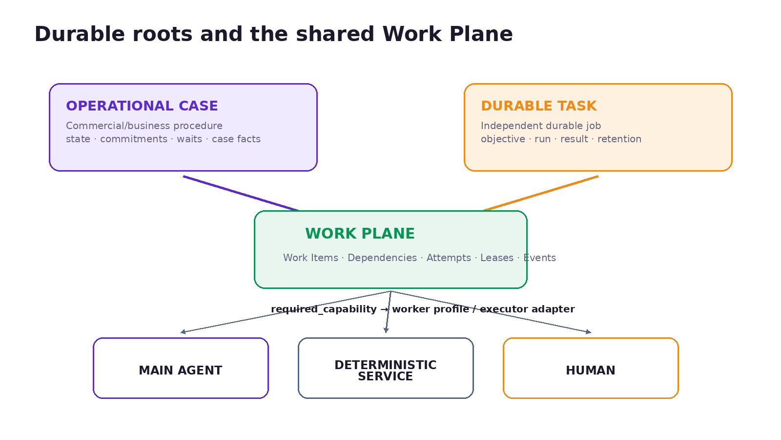
Figure 4 — A Work Item can now be rooted in an Operational Case or an independent Work Run.

The business hierarchy — and its technical refinement
The Session 1 mental model Domain → Case Type → Operational Case → Work Item → Action remains useful for business procedures. The technical architecture now adds an important refinement: not every durable root is a Case. Migration 00074 introduces Durable Tasks and Work Runs; work_items enforce an XOR root of case_id or work_run_id. This prevents batch analysis, OCR, digests or other durable jobs from inventing phantom commercial Cases.
Abstraction | Meaning | Authority / persistence
Domain | A product/semantic responsibility area: Property, Relationship, Demand, Transaction, Network. | Mostly product architecture; realized through case types, workflows, policies, Skills and projections.
Case Type / Workflow Definition | Contract for a class of commercial/business procedure. | Versioned definition + case-type metadata; pinned versions govern runtime transitions for enabled tenants.
Operational Case | Living multi-day business procedure/record. | operational_cases + events + facts/artifacts/approvals + Work Items.
Durable Task | Independent durable job whose root truth is execution/result rather than commercial procedure state. | durable_tasks + work_runs + Work Items.
Work Item | Durable executable unit with its own lifecycle, dependencies, capability requirement and verification contract. | work_items + attempts/dependencies/events.
Attempt | One executor claim/execution of a Work Item. | work_item_attempts; lease/liveness/retry/evidence.
Action | Bounded execution inside an attempt/turn; may reason, respond or use one/multiple Skills/Tools without owning durable continuity by itself. | Agent loop/tool calls/deterministic service/human action records.
Skill | Procedure and judgment guidance — what to do and with what criteria. | Global/account Skills; prompt/runtime context.
Tool | Typed executable capability — how a concrete operation is performed. | Tool catalog + adapters + risk/approval policy.

Why this matters
The separation prevents several common agent-architecture mistakes: treating a prompt as a workflow, treating every long-running job as a commercial Case, treating a Tool call as the durable unit of responsibility, or encoding worker identity directly into workflow definitions. The runtime can instead keep business truth, executable work and execution attempts separate while preserving a coherent user experience.
Source basis: Migration 00074; `docs/operational-cases/architecture.md`; Flexible Workflows Technical Plan §7 and Detailed Implementation Plan Phase 5.

7. Case Plane and Operational Truth

Purpose
Operational Cases exist because the normal chat loop, short HITL pauses, Heartbeat and scheduled prompts do not reliably represent multi-day procedures with external waits, reminders, business decisions, deadlines, re-entry and explicit “where are we?” state. A Case is the durable business procedure; it is not merely a conversation thread.

What the Case currently owns
- Case identity, type, status, current_step, next_action_at, due_at, context_jsonb and optimistic-lock version.
- Append-only Case event history.
- Conversation/channel bindings used for operational routing and notifications.
- Pinned workflow definition for definition-governed tenants.
- Links to Case facts, artifacts, approvals and Work Items in the newer planes.

Operational truth has multiple sources
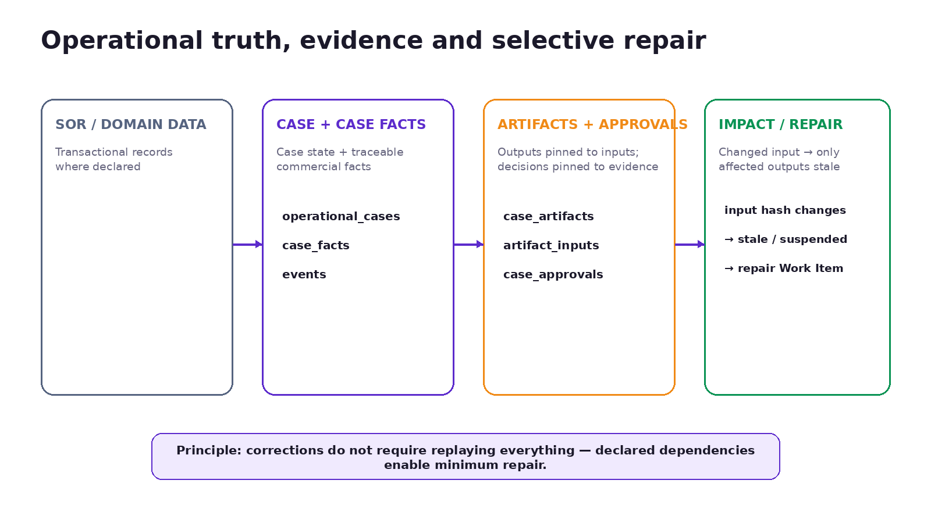
Figure 5 — Operational truth and evidence are deliberately separated from reusable cognition.
Source | What it answers | Authority boundary
CRM / BigQuery / domain SOR | What transactional business records exist in the authoritative system. | Authoritative where declared; Gu OS should not copy every external row into Brain.
case_facts | What commercial fact was asserted/derived in this Case, from what source, with what provenance/confidence, and what superseded it. | Append-only traceable Case truth; corrections create new rows.
Case state | What procedure is alive, where it is, what waits/commitments/next wake-up exist. | Operational responsibility/state of the Case.
Case events | What changed and when. | Append-only history / audit.
Evidence / artifacts / approvals | What output was produced from which inputs and what basis a human approved. | Verification and decision basis.
Conversation | What was said, instructed, corrected or negotiated. | Context; not sufficient operational authority by itself.
Business Brain | What reusable company/entity knowledge is compiled across Cases. | Decision context; never a second Case queue.

`case_facts` is now implementation reality
Migration 00070 creates case_facts as append-only commercial facts with source_kind, source_ref, confidence and superseded_by. The only allowed mutation is the one-shot supersession pointer; a corrected value is inserted as a new fact. Current wiring already records selected intake/characteristic facts and passes changed inputs through the Impact Plane. This is stronger than treating context_jsonb as a universal mutable fact store.
Boundary to preserve
Do not collapse SOR rows, `case_facts`, Case state, events, conversation and Business Brain into one “memory” layer. They answer different questions and require different provenance, mutation and authority rules.

Source basis: Migration `00070_impact_plane.sql`; Brain boundary doc 2026-08-21; operational-case architecture; Investor Narrative Backbone v0.6.

8. Work Plane and Dynamic Execution

Current Work Plane
The Work Plane is no longer only a target. Migration 00069 and packages/workflows implement durable Work Items, attempts, dependency edges, event history, claims/leases, liveness, retries and a dispatcher. This is one of the most important status updates relative to the earlier Team Primer.
- work_items: objective/work type, status, priority, required capability, contracts, retry limits, provenance and result.
- work_item_dependencies: explicit DAG edges; fan-out/fan-in are natural consequences of dependency rows.
- work_item_attempts: one claim/execution attempt with executor, lease, liveness, completion/error/evidence.
- work_item_events: append-only execution timeline.
- Dispatcher: readiness propagation → claim → executor selection → execution → verification → completion/block/review → Case advancement predicate.
- Origins currently include definition_template, impact_repair, agent_proposed, human; not all origins have active consumers.

Dynamic work: current reality vs target
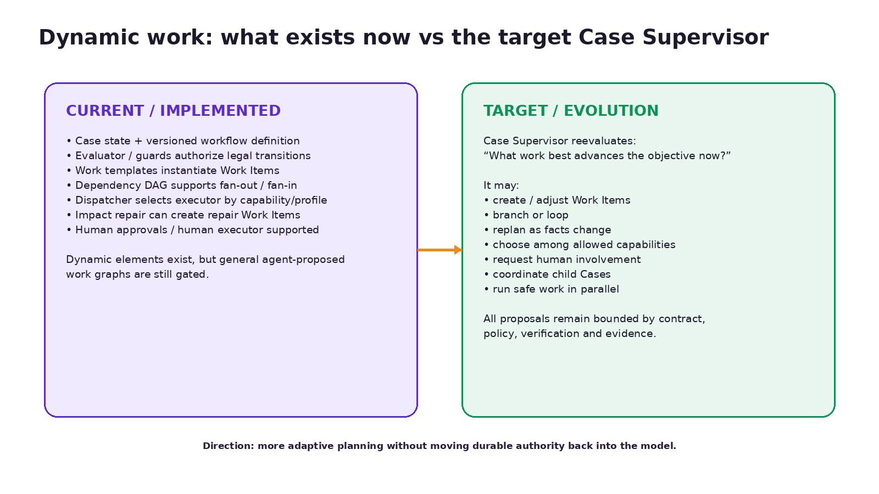
Figure 6 — The current runtime already supports dynamic execution primitives, but the fully general Case Supervisor remains an evolution target.
This distinction is crucial. The system already supports branching definitions, dependency DAGs, fan-out/fan-in, retries, human review and repair work. But a general AI Case Supervisor that can freely synthesize new Work Items and restructure the graph on every wake-up is not yet the normal production authority. origin=agent_proposed is an explicit seam, while general dynamic-workflow activation remains gated in the implementation plan.

Target Case Supervisor
The target Case Supervisor is a reasoning layer that reevaluates a durable objective after an event, scheduled wake-up, human intervention or changed fact. It reads the Case contract/state plus relevant context, then proposes what work best advances the objective now. It can eventually choose among allowed capabilities, propose/adjust Work Items, wait, ask a human, coordinate child Cases or parallelize independent work. It must not bypass workflow invariants, permissions, verification contracts or human-authority rules.
Key principle
A dynamic path does not mean a weak Case contract. The more adaptive the plan becomes, the more important stable objectives, permissions, evidence requirements and deterministic validators become.

Source basis: Migration 00069; `packages/workflows/src/dispatcher.ts`; Detailed Implementation Plan Phase 2 and Phase 5 exit notes; Team Primer v1.2 dynamic Case model.

9. Executors and Capability Resolution

Capability-first dispatch
Workflow definitions and Work Items should request a capability, not hard-code “which agent” performs the work. The runtime resolves the required capability to an allowed worker profile and execution mode. This makes execution policy swappable without rewriting business workflows and avoids premature multi-agent architecture.
Execution mode | Current behavior | Best fit
Main agent | Runs the existing runAgent Case-runner path under the Work Item objective/guardrails/exit criteria. | Work requiring flexible reasoning, contextual judgment and tool use.
Deterministic service | Calls a code-registered deterministic function; no arbitrary DB-string dispatch. | Repeatable calculations, reconciliation, extraction consolidation, stable transformations.
Human | Moves Work Item to review / creates visible internal notification; the human actually performs the item. | Tasks requiring physical action, unavailable credentials, documents/photos, exceptional review or explicit human contribution.

Worker profiles and scope enforcement
Worker profiles are implemented and carry execution mode, allowed Tools/data scopes and model policy. Scope is enforced at executor selection rather than only in a prompt. An item requesting a capability outside the allowed surface can be blocked with an explicit reason. This is architecturally preferable to assuming the model will remember a permission boundary.

What this is not
- Not a generic swarm of named agents.
- Not “one micro-agent per function” as the primary product model.
- Not permission-by-prompt.
- Not hard-coded provider/model identity in the workflow definition.
- Not evidence that every Work Item should use an LLM.
Source basis: Detailed Implementation Plan Slice 2.4 / 3.4; Technical Plan principles 4 and §9; `docs/skills-tools-architecture.md`.

10. Human Involvement and Governance
The canonical umbrella is human involvement. HITL is one blocking mode, not the name for every human touch. This distinction is now explicit in the Technical Plan and should remain the technical vocabulary used in Session 2.

What Gu needs from the human — four kinds
Kind | Question | Examples
A. Action / Tool authorization | May Gu execute this side effect? | Medium/high-risk Tool confirmation, publish, send email.
B. Business decision | Which commercial/legal outcome does the human choose? | Price approval, contract review, publish destination, ownership override.
C. Human contribution / task | What information/action must the person supply? | Upload documents/photos, missing field, OTP/CAPTCHA, owner response.
D. Exception review / intervention | What should happen after failure or ambiguity? | Verifier fail, blocked Work Item retry, publication incident reconciliation.

How the human participates — three modes
Mode | Runtime meaning | Do not confuse with
HITL — blocking | Runtime pauses until a human responds/authorizes. | The umbrella for all human involvement.
Human as executor | The Work Item is assigned to a human; the person performs the work. | A mere approval.
Human-on-the-loop | A human supervises and can intervene without gating every step. | A blocking approval on every action.

Product autonomy lens remains useful
The earlier product/business framing still adds value: routine operational work can often be decided/executed by Gu within policy; strategic/relationship-sensitive work should keep the human in the lead; high-risk/authority-sensitive work generally requires explicit human authorization. This is a product-autonomy lens. It should not replace the technical human-involvement taxonomy above.
Governance rule
Autonomy is earned per operation through evidence and policy. Blanket approval is not a control; habituated approval is often worse than an explicit bounded autonomy policy.

Source basis: Flexible Workflows Technical Plan §3.1; Detailed Implementation Plan standing rule 14; AI-native loops §5; Session 1 autonomy slides.

11. Verification, Evidence, Impact and Selective Repair

Figure 7 — Impact and repair make changed reality explicit rather than silently invalidating prior work.

Verification contracts
The architecture distinguishes executor reports from verified completion. An executor can claim that an output was produced; a verification contract evaluates whether required output/evidence actually satisfies the definition. Workflow Studio validation gates and Work Item output-contract checks are already concrete examples of this principle.

Impact Plane — implemented
The Impact Plane records artifacts against declared input edges and canonical input hashes. When a current fact, upstream artifact or versioned account asset changes, the engine recomputes expected hashes. Only affected artifacts become stale; repair Work Items can be generated with origin=impact_repair. Approvals whose evidence basis changes can be suspended mechanically, but they are not silently revoked; re-approval is a new human decision.

Why this matters for agentic systems
- It prevents “the model remembered the old answer” from becoming operational behavior.
- It enables minimum repair instead of rerunning an entire Case after every correction.
- It makes approvals auditable against the exact evidence snapshot a human saw.
- It separates business methodology (declared dependency edges) from generic field-name heuristics.
- It creates the evidence foundation required for replay, evals and future governed learning.

Concrete Property Optioning example
The current methodology deliberately keeps valuation dependencies separate from commercial-copy dependencies. A bedroom change can stale commercial artifacts without invalidating the valuation chain. A construction-area change can invalidate comparable/valuation/price-recommendation artifacts and suspend price approval. Replacing the commission-contract template should stale only the contract draft. This is a strong example of “hard where reality is hard”: the dependency graph encodes business methodology, while intelligence can operate within it.
Source basis: Migration 00070; `packages/workflows/src/impact-engine.ts`; Detailed Implementation Plan Slices 3.1–3.5; `docs/skills-tools-architecture.md` valuation/comparables boundary.

12. Eventing, Scheduling and Proactivity

Three distinct time/proactivity mechanisms
Mechanism | Purpose | Authority / state
Case wake-up (next_action_at) | Reprocess a durable business procedure when due, after waits, reminders or state changes. | Case state + cron/dispatcher; deterministic due selection.
Scheduled Task | Run a user-approved one-shot/recurrent prompt/job on a schedule. | scheduled_tasks / runs; separate from Cases unless explicitly linked.
Gu OS Heartbeat | Periodic proactive inspection / exception-first work outside normal chat. | Heartbeat config/runs/checklist/prefetchers; “Heartbeat” name is reserved for this feature.

Events can wake work earlier than timers
External responses, internal decisions and integration/webhook events should update durable state and allow immediate continuation rather than waiting for the next scheduled tick. The current Operational Case architecture already associates selected external responses and notifications with Cases. The target event architecture should extend this pattern rather than using frequent blind polling as the default.

Traditional Gu follow-up → Relationship Operations
The current traditional Gu lead follow-up policy is still materially timer/rule driven. The intended Gu OS evolution is not simply “more timers”; it is a Lead Opportunity Case whose next action can be determined from events, policy, context and durable state. A two-hour/24-hour fixed follow-up rule can become one policy input rather than the definition of proactivity.
Source basis: Operational-case architecture; scheduled-task and Heartbeat sections of `docs/architecture.md`; Team Primer v1.2 / Investor Narrative Backbone v0.6 for traditional Gu → Relationship Operations evolution.

13. Business Brain and Knowledge Architecture
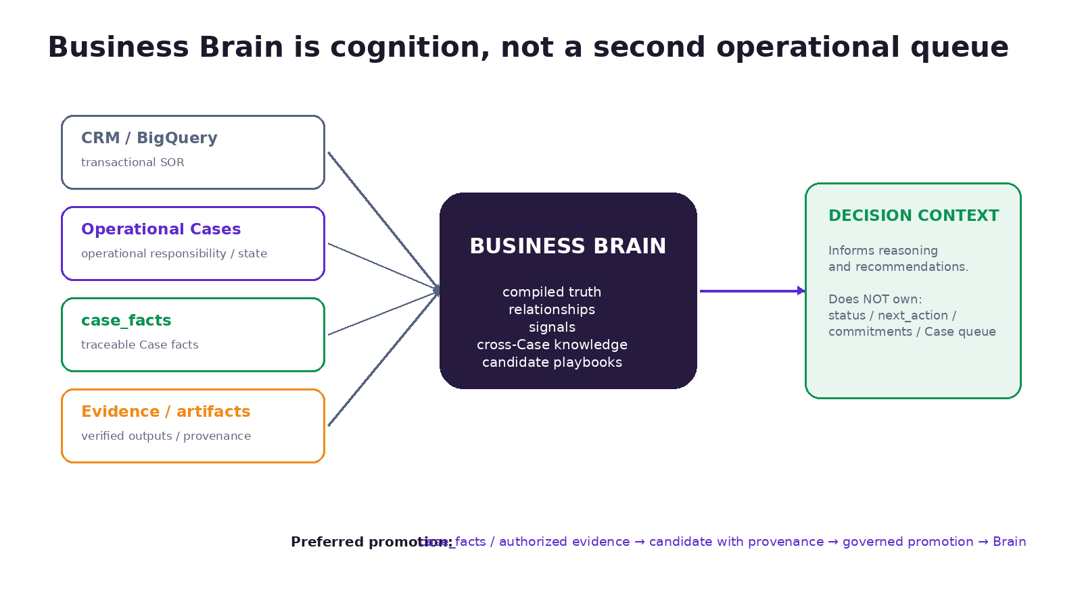
Figure 8 — Business Brain should amplify decisions without duplicating operational state.

Current `business_brain` vs future Business Brain
Concept | What it is | Status
Current profiles.business_brain | Account-scoped stable context: agent identity/description, voice/tone/style/brevity, business-context notes, operating preferences and warehouse binding/legacy compatibility. | Implemented
Business Brain / Brain Layer | Cross-Case compiled entity truth/timelines, verified relations, signals, organizational knowledge, candidate procedures and reusable knowledge artifacts. | Target
G Brain | External/reference architecture used as a design source. Not the canonical Gu OS subsystem name. | Reference
Platform Knowledge and Improvement Plane | Logical platform-scope learning view over incidents/evals/patterns/ADRs/proposals; not a second business Brain database. | Target

Latest ownership boundary — 21 Aug 2026
- Cases own operational responsibility: procedure state, step, waits, HITL and next_action_at.
- case_facts own traceable commercial facts of a Case with provenance and supersession.
- CRM / BigQuery remain transactional systems of record where declared.
- Business Brain owns compiled, reusable cross-Case knowledge: entities, relations, signals and candidate playbooks.
- brain_pages are not an action queue and must not copy canonical status, next_action, commitments, due dates or stage from Cases.

Preferred promotion path
Selective, provenance-preserving promotion
`case_facts` / authorized evidence → candidate with provenance → review where appropriate → Brain timeline / compiled truth / link / signal. No automatic bulk copy from `context_jsonb`.

Why Brain comes after durable work
The architecture is intentionally sequencing durable execution before organizational cognition. Without explicit Cases, facts, evidence and outcomes, a Brain layer risks compiling conversation noise or duplicating mutable operational state. With those primitives in place, Brain can consume higher-quality, attributable inputs and provide decision context without becoming the operational source of truth.
Source basis: Latest commit 49d5f176…; `docs/brain/business-and-platform-brain-boundary.md`; `docs/brain/gbrain-evaluation-and-plan.md` v1.6.1; current `packages/agent/src/business-brain/schema.ts`.

14. Skills, Tools, Providers and OWN / ORCHESTRATE

Skill vs Tool
Concept | Definition | Design rule
Skill | Structured procedure/judgment guidance: what work should be done and with what criteria. | Use for reasoning, context-sensitive sequence, interpretation and business judgment.
Tool | Typed executable capability registered in the Tool catalog. | Use for concrete reads/writes with stable schemas, risk metadata and adapters.
Business wrapper Tool | Domain-shaped deterministic wrapper around technical implementation. | Prefer when a repeated operation can be tested and normalized, e.g. tenant-safe comparable lookup.
Provider | External party/system supplying a capability. | Provider choice is not the same as Tool design or strategic ownership.
Adapter | Internal implementation seam between Tool/runtime and provider/technical service. | Keeps external changes from leaking into domain workflows.

OWN vs ORCHESTRATE
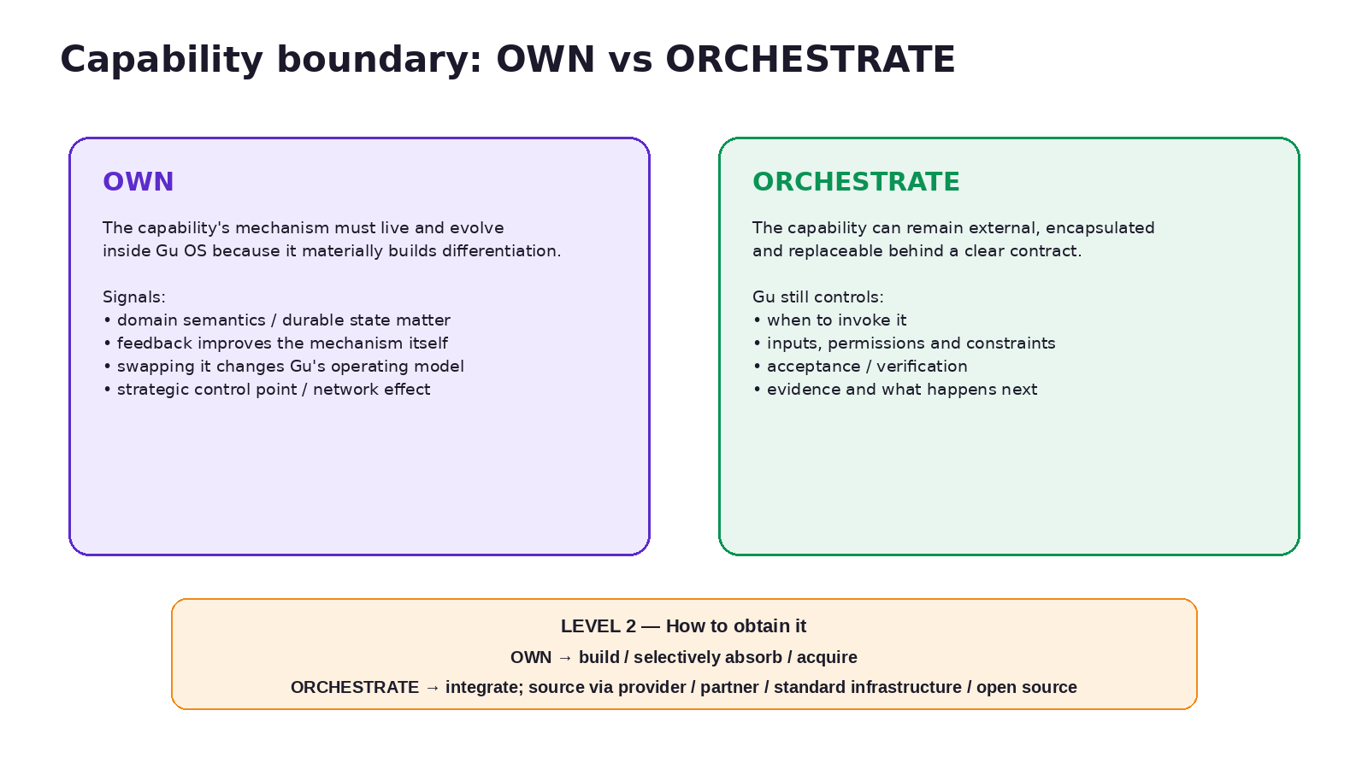
Figure 9 — Strategic capability ownership is a different decision from integration/provider choice.
The framework has two levels. Level 1 asks whether the capability mechanism must live and evolve inside Gu OS because it materially builds differentiation (OWN), or whether it can remain external, encapsulated and replaceable behind a clear contract while Gu preserves work continuity/context/evidence (ORCHESTRATE). Level 2 asks how to obtain it: build/selectively absorb/acquire for owned capabilities; integrate for orchestrated capabilities, sourced from a provider, partner, standard infrastructure or open source.

Examples
Capability | Level 1 | Reasoning
Operational Cases / Work Plane | OWN | Durable semantics, state, governance and execution model are core Gu OS differentiation.
Relationship Operations | OWN / build-absorb | The mechanism for advancing opportunities is a product differentiator, not just an external record.
Business Brain | OWN | Cross-Case organizational cognition and governed knowledge compounding are strategic mechanisms.
Foundation models | ORCHESTRATE | Strategically important, but model training/internals can remain external and replaceable.
WhatsApp / Telegram infrastructure | ORCHESTRATE | Gu needs reliable messaging and channel semantics, not ownership of messaging networks.
Avaclick valuation today | ORCHESTRATE | Gu needs a valuation output/evidence and controls its place in the Case, but the specialized valuation engine can remain external.
MICA specialized rental service | ORCHESTRATE | External specialized capability; Gu should preserve context, permissions, result and continuation.
Ungga shared inventory/network control points | OWN + evolve | Can become a proprietary distribution/routing/network-effect asset.

Important nuance
Learning from an external capability does not require owning it. Gu can preserve the provider output, evidence and downstream business outcome inside its own feedback loop. The boundary moves toward OWN only when the capability’s internal mechanism itself becomes a material, hard-to-replace source of differentiation.

Source basis: `docs/skills-tools-architecture.md`; Investor Narrative Backbone v0.6 / Cofounder Vision v1.1 two-level framework; current Tool/Skill runtime.

15. Conversational Runtime, Multi-Intent and Cross-Channel Continuity

Conversation is interface, not universal state
Web and Telegram currently have channel-scoped agent sessions. Shared user/business state, Operational Cases and decisions can cross channel boundaries, but the short-term transcript is not globally merged. This is intentional: session_id is a channel container, not business truth, and long-term memory is not a transcript store.

Conservative multi-intent handling — implemented
Phase 0 added residual-intent preservation so a gate cannot silently consume part of a mixed message. Phase 4 added a conservative model-backed intent decomposer around the existing deterministic decision-gate chain. When confidence/evidence is insufficient, it falls back safely rather than splitting aggressively. Unmatched question intents can continue to the general agent while handled business decisions preserve their deterministic path.

Cross-channel continuity has three mechanisms
Continuity type | Current / target mechanism | Status
Operational | Case ID + durable state/events + channel/conversation bindings. | Implemented/Partial
Decision | Persistent internal notifications + shared pending-decision router across web/Telegram. | Implemented
General follow-up antecedent | Future conservative resolver over recent turns/structured Turn Artifacts; no universal transcript. | Deferred / Target

No false omnichannel claim
The current product is accurately multi-channel. Exact cross-channel continuation for arbitrary recent query result sets is not yet a general guarantee.

Source basis: Detailed Implementation Plan 0.1 / 4.1; `docs/manuals/gu-os-cross-channel-continuity-architecture.md`.

16. Dynamic / Contextual UI and Artifacts

Interaction principle
Conversation is the primary control surface, but it should not be the only interface. A chart, map, comparison, document, operational board or approval context may need more visual bandwidth than WhatsApp/Telegram/web chat can provide. Gu should select an appropriate surface while preserving the same work context, permissions, provenance and action semantics.

A contextual view does not always require a Case
A one-off comparison, map or analysis can be rendered as a rich view without creating an Operational Case. When a Case does exist, the view should bind to it and preserve Case authority. When no Case exists, the view should still bind to the originating work/turn/artifact context. This avoids the anti-pattern of creating phantom Cases merely to host UI.

What exists now vs target
Surface | Current state | Direction
Web chat / Telegram | Implemented conversational surfaces with shared business semantics. | Remain primary conversational control surfaces.
Operational Case UI | Implemented Case list/detail and impact indicators. | Richer mission-control context without exposing internal plane jargon.
Control Operativo | Implemented admin/operator surfaces for durable roots, Work Items and impact/repair. | May evolve into supervision/HOTL surface.
Workflow Studio | Implemented core catalog/design/resources/compiler flow; rollout/human walkthrough not complete. | Primary governed authoring surface.
Generated/contextual views | Pattern/design target; some concrete reports/views exist but not generalized as a runtime. | Contextual rich views, artifacts, maps/charts, shareable/regenerable assets with permissions/TTL/provenance.

Artifact lifecycle questions
- What authoritative inputs produced the view/artifact?
- Is it a projection that should be regenerated when inputs change, or a durable business artifact that must be versioned?
- Who may see/share it, and does sharing preserve tenant boundaries?
- How long should it remain accessible?
- Does it represent evidence, a decision surface, or merely a visualization?
- If generated dynamically, is the software/view itself disposable while the authoritative data and business rules remain durable?
Source basis: Internal UI/UX dynamic-interface discussion and Team Primer v1.2; `docs/manuals/ai-native-loops.md` regenerable artifacts; cross-channel continuity Turn Artifact direction.

17. Operational Domains
Operational domains are a product/semantic layer over the shared operating kernel. Their purpose is to define business-specific entities, case types, policies, events, skills and projections without duplicating the runtime.
Domain | Responsibility frame | Representative Case/capability examples | Status
Property Operations | Bring a property from intake/capture through a market-ready/publication state. | Property Optioning; document intake; comparables; price decision; package/publication; repair. | Implemented pilot foundation
Relationship Operations | Keep relationships/opportunities alive and advance them toward visits, decisions and transactions. | Lead Opportunity Case; visit coordination; re-engagement; deal progression; portfolio prioritization. | Target / next expansion
Demand Operations | Operate acquisition connected to downstream quality/outcomes rather than only campaign metrics. | Campaign management; attribution; optimization; feedback to targeting/creative. | Target
Transaction Operations | Coordinate work once opportunity enters offer/negotiation/closing territory while preserving human authority. | Offers; documents; financing; negotiation support; closing coordination. | Target / human-led
Network Operations | Mobilize shared inventory, cross-brokerage opportunities and integrated services under explicit governance. | Shared inventory routing; specialized services; commission/attribution rules. | Current shared-inventory asset + Target Gu OS domain

Revenue loop ≠ domain taxonomy
Property Onboarding → Demand Generation → Conversion → Transaction → Outcome Feedback describes where business value occurs. Property / Demand / Relationship / Transaction / Network Operations describe which operating responsibility Gu OS can own. The two maps overlap but should not be forced into a one-to-one schema. For example, Relationship Operations can span conversion, visit lifecycle and selected pre-transaction continuity; Transaction Operations begins when the work changes into offer/document/financing/closing coordination.
Source basis: Investor Narrative Backbone v0.6; Cofounder Vision v1.1; Session 1 domain mapping; current Property Optioning implementation.

18. Traditional Gu → Gu OS Evolution
The recommended evolution is absorption and progressive replacement, not a big-bang rewrite. Traditional Gu has already proven useful lead engagement, intent understanding, inventory matching and visit-oriented progression. Gu OS should preserve those working capabilities while moving fixed timers, implicit state and ad-hoc continuity into the shared durable architecture.

What should remain
- One Gu relationship and conversational experience.
- 24/7 lead engagement capability and existing property-search/matching knowledge.
- Existing CRM/property data integrations and normalized Ungga inventory representation where useful.
- Current customer behavior/evidence and visit-oriented wedge.
- WhatsApp-first prospect channel semantics in the traditional Gu product.

What should progressively move into Gu OS
- Lead/opportunity state and commitments → Lead Opportunity Case / Relationship Operations.
- Fixed 2h/24h timer follow-up → policy/event/state-driven next-work decisions.
- One-off follow-up actions → Work Items with explicit waiting/retry/evidence when durability is needed.
- Implicit “did this happen?” assumptions → evidence/outcome events.
- Manual CRM pipeline upkeep → Gu-managed opportunity progression plus mission-control projection.
- Useful lead/property/deal outcomes → selective facts/evidence and later Business Brain promotion.

What not to do
- Do not duplicate all current Gu tables into Gu OS merely for architectural purity.
- Do not force every lead turn into a Case before there is durable responsibility worth representing.
- Do not replace proven customer flows before Gu OS has equivalent product quality and observability.
- Do not mistake “more follow-up messages” for the target proactive system; the target is situational responsibility, not timer density.
Source basis: Team Primer v1.2; Investor Narrative Backbone v0.6; current Gu product discussion. This migration plan is architecture/product synthesis, not a statement that the Lead Opportunity Case is already implemented in the repo.

19. Workflow Studio and Compiler

The Studio is more implemented than earlier narratives imply
The current repository contains a substantial Workflow Studio foundation. Phase 4 implements business/implementation spec artifacts, a capability map derived from the graph, validation gates, replay-backed simulation, evidence records and a Studio UI that can describe/clarify, inspect specs/gaps, validate, simulate and publish. Phase 5 adds an authoring router and model-backed discovery so natural-language requests can become a case workflow, durable task, reusable Skill, schedule, clarification or redirect-to-chat rather than forcing every request into one artifact type.

Authoring lifecycle
Stage | Purpose | Current status
Discover | Understand request, evidence, gaps and required clarification. | Implemented in code; stabilization evidence exists; manual canary remains.
Classify artifact | Choose case workflow / durable task / reusable Skill / schedule / clarify / chat. | Implemented router.
Compile | Produce typed business + implementation specs and executable graph/task spec. | Implemented core.
Capability resolve | Derive required Skills/Tools/capabilities/assets/integrations from the graph, not model prose alone. | Implemented.
Validate | Schema, graph, cycle/reachability, capability, permission and credential-shape gates. | Implemented.
Simulate / replay | Use shared transition evaluator / synthetic happy-path scenarios. | Implemented foundation.
Human publish | Re-run gates, record evidence, require explicit publication action. | Implemented core.
Rollout / operate | Tenant rollout, production canary, deprecate legacy authoring surfaces, complete attachment flags. | Partial / pending

Studio is not the dynamic runtime
Authoring a workflow definition and dynamically replanning a live Case are separate concerns. Studio creates governed executable contracts. A future Case Supervisor may propose work dynamically inside those contracts, but should not generate ungoverned code/graph semantics directly into production.
Source basis: Detailed Implementation Plan Slices 4.2, 5.3, 5.3.1, 5.3.2; `docs/workflow-studio/README.md`; `packages/workflows/src/compiler/*`.

20. Observability, Testing, Cost, Safety and Tenancy

Testing and replay
- Operational-case self-tests and N0–N5 readiness framework.
- Root self-test aggregation / CI added during flexible-workflows Phase 0.
- Historical workflow-definition replay using the production evaluator.
- Work Plane contention, stale-claim, dependency/fan-in and retry self-tests.
- Synthetic and live Work Plane soak evidence with concurrent runners.
- Compiler validation/simulation self-tests and Studio N-run discovery evidence.
- Impact-engine scenarios explicitly test under- and over-invalidation.

AI usage and outcome economics
ai_usage_events records model calls, token categories, cost, latency, model role and correlations to turn/Case/workflow/work-item context. The AI-native loops document correctly notes that the missing business step is outcome correlation, not basic inference metering. Tokens and model cost are inputs; the optimization target is validated business outcomes relative to inference cost, human effort and rework.

Security / tenancy
- New workflow/work/impact tables carry tenant/user scope and RLS; query helpers require user scope.
- Service-role server paths mean RLS remains defense in depth; application-level tenant arguments are still a critical invariant.
- External/contact-sourced facts preserve provenance and should not satisfy approval postconditions without human authority.
- Worker scope enforcement is done at runtime selection, not only by prompt.
- Workflow/Skill publication is governed; generated scripts are not download-and-run production code.
- Cross-channel movement must never widen authority or cross tenant boundaries.

Production proof remains a separate axis
Architecture maturity ≠ market maturity
A component can be implemented and well tested while still lacking broad customer usage, canary duration, operational support evidence or repeatable business outcomes. The roadmap should track these as separate proof dimensions.

Source basis: Detailed Implementation Plan Phases 0–5; AI-native loops; cross-channel continuity; architecture analysis security findings.

21. Current vs Target Architecture
Area | Current / implemented reality | Target / evolution
Conversation | Web + Telegram, Skills/Tools, decision gates, conservative multi-intent handling. | More channels, contextual UI, evidence-gated antecedent continuity where justified.
Cases | Durable state/events/waits, pinned workflow authority for enabled tenants. | Broader domain Case types and more event-driven/situational policies.
Work Plane | Work Items/DAG/attempts/leases/three executor modes. | Safe agent-proposed dynamic work and richer supervisor planning where evidence supports it.
Impact / evidence | Facts/artifacts/inputs/approvals, selective repair and evidence-bound approval chain. | Broader domain coverage, stronger verifiers, outcome correlation across loops.
Durable Tasks | First-class roots and Work Runs; E2E/inputs rollout partially open. | Mature independent durable jobs with consistent authoring/results/retention.
Studio | Compiler/gates/simulation/publish + NL router/discovery foundations. | Complete human walkthrough/canary, legacy authoring retirement, governed skill-package interoperability.
Business Brain | Current profile JSONB + data binding; future Brain design only. | Selective promotion, compiled cross-Case knowledge, relations, signals, governed candidate procedures.
Relationship Operations | Traditional Gu lead wedge plus Gu OS foundations; no broad Lead Opportunity domain yet. | Persistent Lead Opportunity Cases, portfolio prioritization, visit/deal continuity.
Demand Operations | Not a broad current Gu OS domain. | Campaign/acquisition Cases connected to downstream outcomes.
Dynamic UI | Case/Control/Studio views; conversation remains primary. | General contextual rich views/artifacts selected per work context.
Network | Shared inventory/product asset and integrations exist outside a mature Gu OS network domain. | Governed routing, shared opportunities, integrated services and stronger network effects.

Source basis: Repository + internal product narrative reconciliation.

22. Recommended Technical / Product Roadmap
The repository already contains more flexible-workflow infrastructure than the earlier technical presentation outline assumed. The next roadmap should therefore emphasize activation, domain productization and outcome proof rather than continuing to add generic architecture in isolation. The sequence below is a recommendation/synthesis, not a verbatim repo commitment.

Figure 10 — Recommended sequencing: operationalize the foundation before expanding intelligence and domains.

Stage A — Stabilize and prove the implemented foundation
- Run real-customer Property Optioning E2E through the current workflow/work/impact planes.
- Complete the human Workflow Studio walkthrough and tenant/environment rollout gates.
- Close remaining durable-task input/file UX and live E2E gaps.
- Run the deferred market canary for workflow enforcement; remove duplicated legacy guards only after evidence.
- Add/strengthen outcome correlation, operational alerts and support runbooks.
- Clarify which legacy/current Case path remains active per tenant and define cleanup criteria.

Stage B — Productize Relationship Operations
- Define the Lead Opportunity Case contract and explicit lifecycle/acceptance/outcome vocabulary.
- Replace fixed-timer follow-up with event/policy/context-driven next-action logic where appropriate.
- Model visit request → scheduled → attended → downstream transaction signal as durable evidence, not only conversation.
- Develop Portfolio Supervisor/prioritization only after Case-level semantics are stable.
- Reuse current Gu matching/search capabilities rather than rebuilding them inside the Work Plane.

Stage C — Close the outcome loop
- Correlate lead/opportunity actions, visits and transaction signals to workflow/work versions.
- Expose outcome/evidence views suitable for operators and product learning.
- Use results to improve policy/proposals under governed evaluation; do not jump directly to autonomous workflow rewriting.

Stage D — Activate Business Brain selectively
- Promote high-value case_facts/authorized evidence into entity timelines/compiled truth with provenance.
- Prioritize retrieval that materially improves Case Supervisor/Gu decisions.
- Keep action queue and next-action authority in Cases/Heartbeat/scheduled tasks.
- Add graph/signals only where they improve operational outcomes and can be governed.

Stage E — Expand domains and network
- Demand Operations: campaign goals, attribution and downstream visit/transaction feedback.
- Transaction Operations: document/financing/closing coordination with strong human authority.
- Network Operations: scale shared-inventory density, routing, service orchestration and governance.
- Revisit OWN/ORCHESTRATE boundaries as proprietary data/feedback changes the strategic value of capabilities.
Source basis: Recommendation based on repo dependency graph + Investor Narrative Backbone v0.6 / Team Primer v1.2 / Cofounder Vision v1.1. Not a canonical repo plan unless subsequently adopted.

23. Risks, Open Decisions and Technical Debt
Risk / decision | Why it matters | Recommended treatment
Broad production validation gap | Synthetic/live internal soak is not the same as sustained customer traffic and operational support. | Track canary duration, incidents, rollback and business outcomes separately from code completion.
Legacy/v2 coexistence | Case v1 path and newer work-plane paths can increase cognitive/maintenance cost. | Make tenant rollout state explicit; retire duplicate guards only after canary evidence.
General dynamic work activation | agent_proposed exists as seam but broad dynamic graph construction can expand risk quickly. | Gate by verifier coverage, allowed capabilities, rollback and measured need.
Business Brain overreach | A Brain action queue would duplicate Cases and drift. | Preserve 2026-08-21 boundary; promote selectively with provenance.
Outcome correlation | Inference/cost metering without business-outcome linkage limits optimization. | Prioritize visit/transaction outcome joins and version correlation.
Organization/role model | Current identity/tenant model remains simpler than future brokerage team/org sharing needs. | Do not overload user_id; activate org/team ownership only with explicit schema/permission plan.
Cross-channel expectations | Users may expect exact continuation across channels even when general antecedent resolver is not active. | Use clear product claims, preserve Case/decision continuity, add resolver only after evidence gate.
Studio rollout | Core code can be mature while human authoring UX/canary is incomplete. | Complete manual walkthrough, flag/telemetry rollout and legacy authoring retirement criteria.
Attachment/file safety | Generic file pipeline foundation exists; malware/scanning/retention/flags require operational completion. | Keep explicit environment rollout gates; no broad “safe file platform” claim yet.
Provider dependency / OWN boundary | Critical external providers can become architectural chokepoints. | Use adapters/contracts, preserve evidence/state internally and periodically reassess strategic ownership.
Traditional Gu integration | Two systems can drift in lead/opportunity state if migration is ad hoc. | Define event contracts, source-of-truth boundaries and staged absorption before replacing production behavior.
UI abstraction leakage | Operator plane vocabulary can overwhelm brokers. | Keep technical state in Control Operativo; expose business-safe projections in customer surfaces.

Open product decisions worth resolving before Session 2 roadmap freeze
- Exact Lead Opportunity Case boundary: when does a prospect interaction become durable Case responsibility?
- What concrete signals should Portfolio Supervisor use first, avoiding fabricated close probabilities?
- Which external-channel events are sufficiently reliable to wake/replan a Case?
- What is the first Business Brain entity set and promotion policy that creates measurable value?
- Which contextual view types deserve reusable product surfaces vs generated situational views?
- What Network Operations governance is required before cross-broker routing can scale?
- Which OWN/ORCHESTRATE boundaries should be revisited after 6–12 months of outcome data?

Appendix A — Architecture Reconciliation Matrix
This matrix is the explicit bridge between the current repository and the narrative documents. It should be updated before future architecture presentations when material repo changes land.
Concept | Repository status | Narrative alignment / action
Gu / Gu OS distinction | Product-level, supported by one agent runtime plus internal planes. | Aligned; keep one Gu experience.
Conversation ≠ operational truth | Strongly supported by Cases/facts/events/evidence architecture. | Aligned.
Domain → Case → Work Item → Action | Cases + Work Plane implemented; Durable Task alternate root adds technical refinement. | Keep simplified hierarchy in business material; add Durable Task in technical deep dive.
Dynamic workflow / Case Supervisor | Dynamic primitives implemented; general AI-proposed dynamic work not broadly active. | Mark Supervisor as evolution, not current generalized runtime.
Case facts | Implemented and impact-wired. | Upgrade any older “future” labels.
Human involvement | Canonical taxonomy + multiple runtime modes. | Aligned after Team Primer v1.2 update; use technical taxonomy in Session 2.
Business Brain | Future Brain Layer; current JSONB limited; action-queue leftover removed. | Aligned conceptually; technical status must stay Target.
Workflow Studio | Core implemented; rollout/human walkthrough partial. | Earlier “very early” language is now conservative/stale; update technical deck.
Durable Tasks | Implemented foundation. | Add explicitly to technical architecture; no need to complicate investor story unless relevant.
POSEER / ORQUESTAR | Product decision framework; repo supports Tool/provider abstraction but does not itself define commercial framework. | Use as architectural sourcing/ownership lens, clearly labeled synthesis.
Relationship Operations | Not yet broad repo subsystem; common kernel can support it. | Strategic target; do not label current implementation.
Demand Operations | Target product domain. | Strategic target.
Contextual UI | Current operator/Studio UI + target richer views. | Aligned if “Case when it exists” caveat retained.
Network operations | Shared inventory current product asset; mature Gu OS network domain not implemented. | Keep current asset vs future network effect distinction.
AI-native learning | Governed loop model documented; broad self-improvement not live. | Aligned; preserve Vision/Target labeling.

Appendix B — Glossary
Term | Definition
Action | Bounded immediate execution inside a turn/attempt; may include reasoning and multiple Tool calls but does not own durable continuity.
Business Brain | Target Gu OS cognition layer for compiled cross-Case organizational knowledge; distinct from current business_brain JSONB.
Case Supervisor | Target reasoning layer that determines what work best advances one Operational Case now, within hard boundaries.
Case Type | Classification/contract for a kind of Operational Case; tied to workflow definition and root Skill metadata.
case_facts | Implemented append-only traceable commercial facts for a Case, with provenance/confidence/supersession.
Durable Task | Independent durable work root whose primary truth is execution/result rather than commercial Case state.
Evidence | Mechanically admissible record demonstrating a gate/verifier/condition; distinct from model claims.
Heartbeat | Reserved term for Gu OS proactive periodic execution feature; not executor liveness.
HITL | Blocking human-in-the-loop mode; one mode within broader human involvement.
Human-on-the-loop | Human supervision/intervention without blocking every step.
Impact Plane | Facts/artifacts/input dependencies/approvals + invalidation/repair mechanisms.
Operational Case | Durable multi-day business procedure with explicit state, waits, governance and lifecycle.
ORCHESTRATE | Keep capability mechanism external/replaceable behind a contract while Gu controls its participation in work.
OWN | Keep capability mechanism inside Gu OS because it materially builds differentiation and must evolve with the product.
Skill | Procedure/judgment instructions describing what work to do and criteria.
Tool | Typed executable capability describing how a concrete operation is performed.
Turn Artifact | Target bounded structured result from a turn for future follow-up; not universal memory.
Verification contract | Declared criteria/evidence needed for work to count as complete.
Work Item | Durable executable unit with state, dependencies, required capability and verification contract.
Work Plane | Shared execution substrate for Work Items, attempts, dependencies, claims/leases and dispatch.
Workflow Definition | Versioned executable contract governing legal Case transitions, guards, templates, postconditions and completion.
Workflow Studio | Governed authoring/compile/validate/simulate/publish surface for workflow and other durable-work artifacts.

Appendix C — Source Register

Canonical repository sources used
- docs/README.md — documentation authority map and status vocabulary.
- docs/architecture.md — concise current stack / implemented runtime overview.
- docs/manuals/architecture-manual.md — integrated current/target architecture.
- docs/manuals/gu-os-flexible-workflows-technical-plan.md — accepted flexible-workflows target architecture.
- docs/manuals/gu-os-flexible-workflows-detailed-implementation-plan.md — implementation status, slices, contradiction log and evidence.
- docs/operational-cases/architecture.md — current Operational Case runtime and lifecycle.
- docs/skills-tools-architecture.md — Skill/Tool/wrapper/adapter boundaries.
- docs/brain/gbrain-evaluation-and-plan.md — Brain Layer design reference and current Gu OS mapping.
- docs/brain/business-and-platform-brain-boundary.md — current canonical Business Brain ownership boundary.
- docs/manuals/ai-native-loops.md — governed Observe→Decide→Act→Evaluate→Learn model.
- docs/manuals/gu-os-cross-channel-continuity-architecture.md — cross-channel continuity boundaries.
- docs/workflow-studio/* — authoring, capability resolution, qualification and rollout.
- packages/workflows/src/* — evaluator/dispatcher/executors/evidence/impact/compiler code.
- packages/agent/src/operational-cases/* — current Property Optioning domain execution code.
- packages/agent/src/business-brain/* — current narrow business_brain runtime support.
- packages/db/supabase/migrations/00069_work_plane.sql — Work Plane.
- packages/db/supabase/migrations/00070_impact_plane.sql — case_facts/artifacts/inputs/approvals.
- packages/db/supabase/migrations/00074_durable_task_roots.sql — Durable Task roots + Work Run + Studio authoring sessions.

Internal narrative sources used for product/strategy alignment
- Ungga Investor Narrative Backbone v0.6.
- Ungga — From Gu to Gu OS Team Primer v1.2.
- Ungga — Gu to Gu OS Strategic Vision for Cofounders v1.1.
- Session 1 — Vision, Product & Operating Model v1.2 Reviewed Final.
- OWN / ORCHESTRATE Decision Framework v2.0.

Source-discipline note
Sections describing repository status are source-derived from the snapshot above. Sections explicitly labeled recommendation, synthesis, product mapping or roadmap combine repository constraints with the current Ungga product strategy. Those recommendations should be promoted into canonical repo documentation/ADRs only after the team accepts them.
Humans lead. Gu gets work done.

